Amazon Web Services Influence in MPC

MAN 4522 Final Project

December 9th, 2022

Florida Polytechnic University

Bruce Rodriguez

Donavan Dodson

Owen Telis

Sulman Mohamed

# Introduction

Amazon Web Services (AWS) is an extremely popular service used by millions for its flexibility, scalability, and reliability in meeting any and all business needs. When investigating new technologies capable of enhancing a company and its ability to better manage its manufacturing planning and control activities, AWS was a platform capable of meeting those criteria.

We chose Amazon AWS as the subject of our final project because of its importance in the manufacturing and computing industry. As of the first quarter of 2021, AWS had over a third of the market share at 32.4%. The platform has locations in over 245 countries and territories. AWS provides a platform for businesses to grow and scale their services as much as they need. The services are like a utility company, where businesses can pay only as much as they need. This lowers the barrier of entry for new businesses since, allowing more flexibility, instead of dumping costs into infrastructure that they may not need in the future. AWS also provides many services that can be used for a wide variety of activities. All the services that are provided are up to Amazon’s own standard of quality, since the system was originally designed to help Amazon’s own supply chain management. The cloud provider currently provides services to 1.45 million businesses. For these reasons, we decided that AWS would be a great topic for our paper, to analyze what kind of services they provide, and why they are important to many businesses. We will be going over some interesting services they provide and studying how those services are useful in the manufacturing and computer world.

# Tools

## AWS Connect

AWS Connect is a tool that allows the quick set up of contact centers in minutes that can scale to support the needs of your customers. It has multilingual conversational AI, and IVR which can be used to create self-service tools to interact with customers. It allows for the automation of simple tasks that would otherwise need a customer service representative. Companies that choose to use AWS Connect often save up to 80 percent when compared to other contact center solutions. It has no upfront licensing fees and long-term contracts. Machine learning is a large component of AWS Connect as it increases agent productivity and customer experience. Forecasting, Capacity planning and scheduling are all included in the tool and Machine learning allows for them to be accurate when predicting requirements of the company.

## AWS Supply Chain

AWS Supply chain is a cloud-based application that unifies data, has ML-powered insights, and offers built in to allow collaboration between systems. It connects existing ERP to the supply chain management systems without requiring the company to restructure, replatforming, licensing fees or long-term commitments. A large feature is the ability to generate accurate demand forecast to reduce stock outs. Machine Learning allows for an increase in demand planning accuracy the more the feature is used. . A competitive advantage gained by knowing your supply and demand accurately and being able to manage your business is a large part as to why companies are choosing to use tools built into AWS.

## AWS EC2

The Amazon Elastic Compute Cloud (Amazon EC2) is a compute platform – a data environment where software implementation occurs or a piece of software is executed – with over 500 instances (Regions and Availability Zones). Regions consist of one more Availability Zones. Launching instances in multiple Availability Zones is better because it helps protect the applications if one location goes down. When using EC2, they provide the choice of the latest processor, storage, networking, operation system, and purchase model to match the needs of a workload (Daly, 1987).

When it comes to operating systems, they provide an ever-growing list, including Microsoft Windows and Linux distributions, such as Amazon Linux 2, Ubuntu, and more. The types of processors they provide are Intel, AMD, and Arm. Arm processors are not as powerful as Intel but are more mobile-friendly in most cases. When it comes to networking, they provide up to 400 Gbps Ethernet. This high amount of data transfer is helpful if someone wants to train and deploy a machine-learning application. Amazon also used per-second billing. This method means the user will only pay for what is being used. It takes the cost of unused minutes and seconds within an hour off of the bill (Daly, 1987).

## AWS CloudWatch

The Amazon CloudWatch helps streamline the infrastructure and application maintenance. It achieves this by collecting and visualizing real-time logs, metrics, and event data. As well as alarms and automated actions set to activate at predetermined thresholds to help improve operational performance. CloudWatch can seamlessly integrate with more than 70 AWS services. These integrations allow for simplified monitoring and scalability (Jenkins, 2000).

The tool also uses automated dashboards to help troubleshoot operational problems with actionable insights derived from the logs and metrics gathered. There are many ways to monitor an application. CloudWatch allows the user to do logs and metrics correlations, monitor if the application has internet issues, anomaly detections, and more. There are also many ways to analyze the application. The user can monitor trends and seasonality with 15 months of metric data. CloudWatch can provide fast, flexible, SQL-based metric insights and more (Jenkins, 2000).

AWS provides four example use cases: Monitor application performance, perform root cause analysis, optimize resources proactively, and test website impacts. The below image shows how Amazon CloudWatch helps users collect, monitor, and understand their use of AWS resources and was taken from the AWS website (Jenkins, 2000).

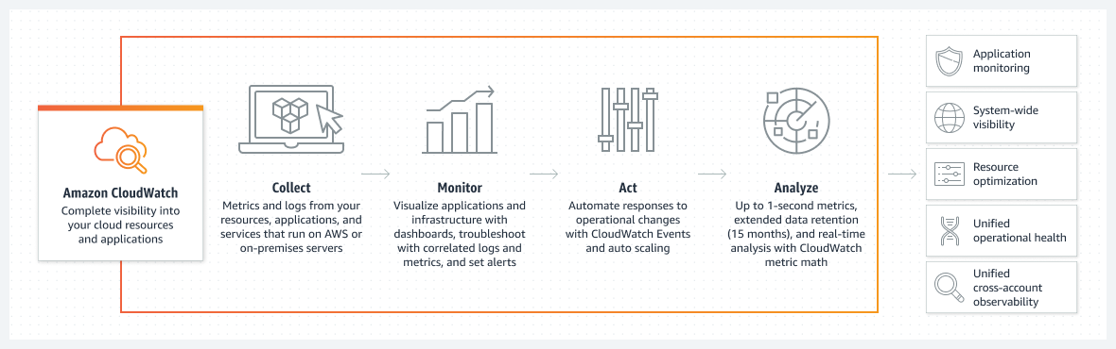

Figure 1: How the AWS CloudWatch Works

## AWS Elastic Beanstalk

The Amazon Elastic Beanstalk deploys web applications so the user can focus on the business. This tool allows the user to upload and efficiently deploy web applications. Elastic Beanstalk lets users focus on writing code rather than provisioning and managing infrastructure. Users also can select and retain complete control of the optimal AWS resources for powering the applications. Elastic Beanstalk has adjustable settings to scale an application, allowing for handling peak traffic peaks while minimizing costs (*AWS Elastic Beanstalk*).

AWS provides four example use cases for Elastic Beanstalk: quickly launch web applications, create mobile API backends for an application, and re-platform critical business applications. The below image shows how AWS Elastic Beanstalk lets users create environments to upload and set up applications and was taken from the AWS website (*AWS Elastic Beanstalk*).

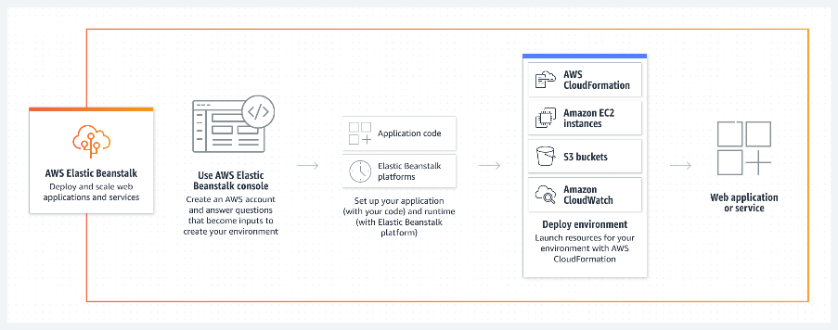

Figure 2: How the AWS Elastic Beanstalk Works

## AWS Lambda

AWS Lambda is the 6th aspect of AWS discussed in this paper. AWS Lambda is known for its serverless, and event driven computing service. It allows a user to be able to run code via a large variety of applications and other backend services. All the previous statements can be done without the aid of provisioning and or managing servers. That part is what sets it apart and makes it a solid choice for potential users. AWS Lambda can be broken down into the different tasks it can accomplish. These include but are not limited to; File Processing, Stream Processing, Web Application, IoT Backends, Mobile Backends. Each of which can be broken down further into 5 to 6 steps.

File processing begins with a photograph being taken. That photo is promptly uploaded to an S3 bucket. This triggers Lambda which then would run a code that would resize the image. Lastly the image is resized into what would fit for web, mobile, and tablet viewing.

Stream processing begins when social media stream is loaded into Kinesis, triggering Lambda. AWS Lambda then runs a code that would generate hashtag trend data. This newly produced hashtag data is stored in DynamoDB allowing it to become available to users.

Web Application starts with Fron-end code typically used for weather apps hosted by S3. Firstly, a user would click a link when they wish to get their local news and weather information. Next, the app would make REST API call to an endpoint, triggering Lambda. Lambda runs a code meant to retrieve the weather information and return the data back to the user who was mentioned in the first step.

In regard to Iot backends an example of its implementation is when a tractors sensor, for example sends data to Amazon Kinesis. Amazon Kinesis would then take and stream the captured data for the purpose of it being processed by Lambda, triggering it. Lambda then promptly runs a code for the purpose of detecting trends in the retrieved data. The purpose of this step is to assist in the detection of anomalies. Lastly the order is automatically placed for a replacement for the tractor.

The final aspect of AWS Lambda to elaborate on is Mobile Backends. This process is initiated when a user post status is updated. The mobile app would make REST API call to an endpoint, triggering Lambda, which in turn would run a code meant to look up friends and push an update notification out. Then the users' friends receive that pushed notification about the status update.

## Case Studies

Many companies have had success implementing AWS into their supply chain management, in this section we’ll be reviewing some of those case studies. Some of the notable companies that have integrated AWS into their systems include Siemens, Georgia-Pacific, LG Electronics, and Volkswagen Group.

Siemens has seen many benefits using AWS. In 2019, the company decided to use AWS Lambda and Amazon DynamoDB to perform analytics and hold the results of those processes. This system helped them monitor equipment and operations in their power plants. These alerts ranged from component failures to out-of-tolerance process conditions; all these alerts needed to be processed in order of importance to help reduce stress on teams. By using AWS services, Siemens was able to successfully reduce the number of alerts they received from 5,000 a day to 500 a day, a 90% reduction. The company has many other success stories using AWS, such as using AI-enabled cybersecurity to handle 60,000 cyber threats per second.

Another company that has seen success with AWS is Georgia-Pacific. Their case study shows how well AWS can handle large amounts of data storage and how easy it is to use. The company was able to transfer 50 TB of production data, which was more than 500 billion records, from hundreds of manufacturing machines to the cloud. They used Amazon Kinesis to stream data straight from the equipment to a data lake using Amazon Simple Storage Service (S3). Another useful service is Amazon SageMaker, a machine-learning service. Georgia-Pacific uses Amazon SageMaker to provide real-time feedback on machine operators regarding the optimum machine speeds and adjustable variables.

An interesting challenge that LG faced was remote work, but with AWS, the company was able to overcome these hurdles. The company is based in Korea but employs over 75,000 people in over 120 operations across the world. Without the proper tools, efficiently and accurately sharing data and information across so many locations becomes very difficult. One of their problems was that many users had to download data from servers to their local desktops. A process that could take hours of work. However, in 2013 LG decided to switch to NICE DCV, a remote display protocol that allows users to remotely access desktops and stream applications. There were other products like NICE DCV but this one provided the greatest resolution and lowest latency, while being simple to manage.

Finally, Volkswagen Group has made use of AWS IoT services to create an industrial cloud. Volkswagen has 124 factory sites, all with their own machines and processes that need to be monitored. They also own 15 different brands that have different requirements and needs for the products they are making. By using AWS IoT services, all of the data from all of these sites can be collected and stored in one place. The industrial cloud has led to a 30 percent increase in productivity, 30 percent decrease in factory costs, and €1 billion in supply chain savings. And the company plans to go even beyond their manufacturing needs, using AWS to empower ridesharing services as we all connected vehicle needs.

# Conclusion

In conclusion, AWS is a power service that many companies use to empower their supply chain needs. AWS is flexible, scalable, and secure. It will help companies lower their IT/OT costs, allow for faster innovation with the wide range of services provided, help improve operations as companies can easily store and access data, and enhance their security by utilizing amazon’s security-sensitive architecture. The cloud can help companies with their data needs without the need to invest in architecture and use AWS services to utilize that data. The examples we have outlined show that AWS is a powerful platform that many companies should utilize to help their manufacturing, supply chain, and data needs.

# References

Daly, D. J. (1987). *Amazon EC2 features*. Amazon. Retrieved December 5, 2022, from https://aws.amazon.com/ec2/features/?trk=ec2_landing

Daly, D. J. (1987). *Amazon EC2*. Amazon. Retrieved December 5, 2022, from https://aws.amazon.com/ec2/

Jenkins, G. (2000). *Amazon CloudWatch Features*. Amazon. Retrieved December 5, 2022, from https://aws.amazon.com/cloudwatch/features/

Jenkins, G. (2000). *Amazon CloudWatch*. Amazon. Retrieved December 5, 2022, from https://aws.amazon.com/cloudwatch/

AWS Elastic Beanstalk. (n.d.). Retrieved December 5, 2022, from https://aws.amazon.com/elasticbeanstalk/

AWS Supply-Chain. (n.d.). Retrieved December 5, 2022, from

https://aws.amazon.com/aws-supply-chain/

AWS Connect. (n.d.). Retrieved December 5, 2022, from

https://aws.amazon.com/connect/

Miner, J. C. (1984). *Manufacturing*. Amazon. Retrieved December 5, 2022, from <https://aws.amazon.com/manufacturing/>